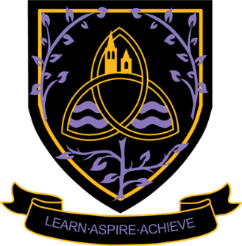
Employment – Straight into the world of work.
Apprenticeships – Earn whilst you learn. Furthering your skills set, whilst gaining experience and networking with people to secure your employment future – up to Higher and Degree level Apprenticeships.
University – The course you have selected and focus your studies on one area.
Higher Educations Courses – You may want to access Higher Education through local or national colleges: HND, HNC, Access to courses, top up degree courses and even a career change.

Don’t forget to keep in contact and let us know how you are doing and what you are up to. Maybe you could come back and chat to the students and staff.


Support on results day; with internal and external careers guidance

Careers meetings with internal and external careers teams
Continued support with UCAS, Apprenticeship and Employment Applications
Intentions and destinations. To help us to support you with your post 18 options

Access to local employers to help identify and develop your network
Careers networking with a wide range of local and national businesses
Careers talks, trips and events to support your post 18 options
Life Skills lessons. Further developing your skills and knowledge for the world of work or University life

Ongoing Careers support from the Careers Team
Year 13

NAW & NCW – National Apprenticeship & National Careers Week.


NAW & NCW –
National Apprenticeship and National Careers Week.
Careers meetings with internal and external careers teams
Intentions and destinations. To help us help you plan for your post 18 options
A wide range of employer encounters through Work experience, Employability workshops, Careers talks and activities in different subject
Life Skills Lessons. Developing your skills and knowledge of Post 18 options
UCAS Applications. If you are wanting to experience University life.
Year 12
Increased Interactions with businesses through the careers network

Ongoing Careers support from the Careers Team

HE Fair – Visit to a venue which showcases a large selection of Universities and a chance to find out what they can offer


Careers – it’s about more than just jobs!
Welcome to Wigston College

